FOR IMMEDIATE RELEASE
Signature Sound and Simplicity
The CX 80U and HD 400U bring high-performance digital audio to the modern listener

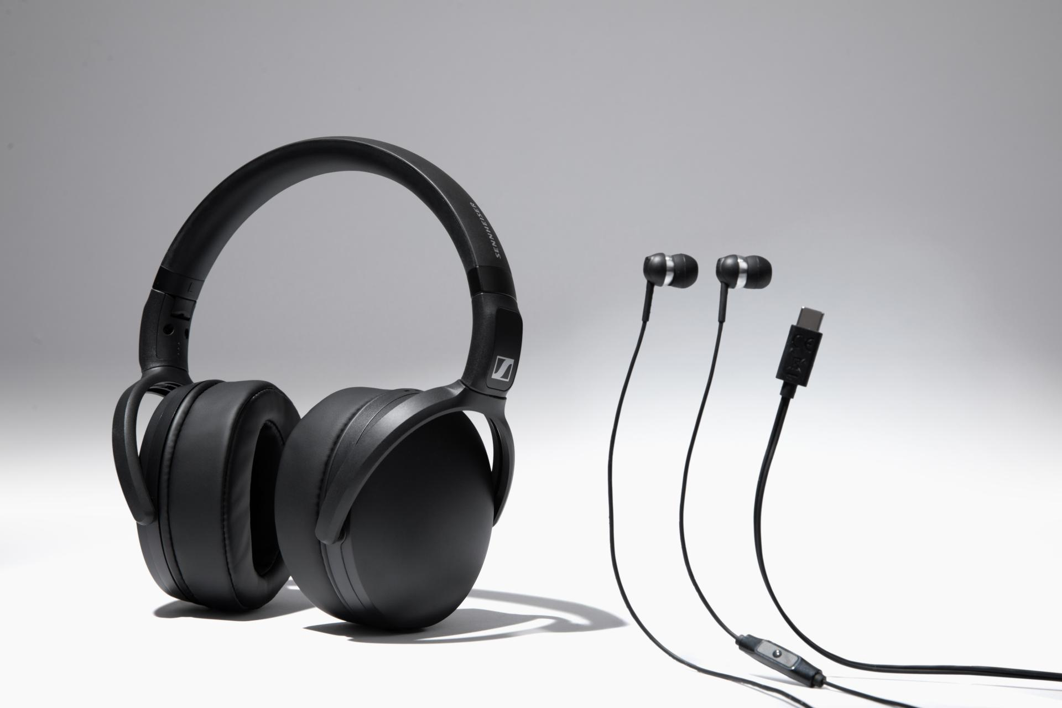

Hanover, Germany – January 26, 2026 – The Sennheiser brand today announces the
CX 80U earbuds and HD 400U headphones, bringing a connectivity update to their fan favorite CX 80S and HD 400S. Both models feature the USB Type-C connection that ensures a direct, low-latency lossless path from the source to the ears. With support for 24-bit, 96 kHz digital audio playback, each bring renowned Sennheiser sound to practically any modern mobile phone, tablet, handheld game console, or PC.

“The HD 400U and CX 80U are made for anyone who wants to just plug in and go—ensuring that convenience never comes at the expense of sound quality,” said Christian Ern, Senior Product Manager. “By combining our acoustic heritage with the ubiquity of USB-C and an in-line remote mic, we’ve made it easier than ever to get the Sennheiser sound from the entertainment and productivity apps that we rely on every single day.”

HD 400U
The compact HD 400U headphones carry forward the legacy of the HD 400S, known for its bass-driven acoustics and backpack-friendly portability. The closed-back design provides exceptional passive isolation, ideal for focused listening at home, work, or school. The

included storage pouch and detachable cable keep them tidy during transport, ready for a listening session anytime, anywhere.

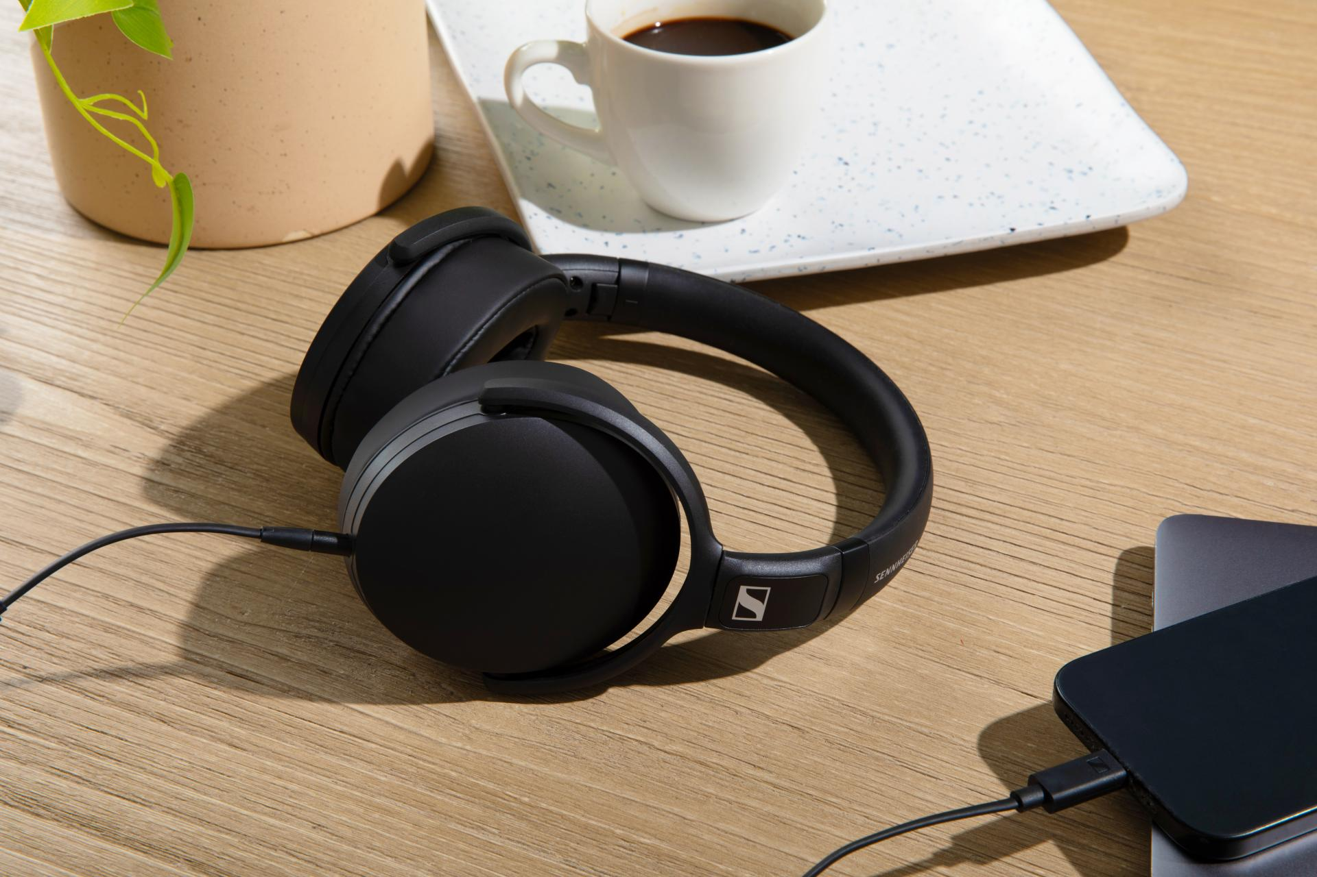

CX 80U
For those that prioritize a compact, in-the-ear fit, the CX 80U picks up where the CX 80S left off with balanced-yet-punchy sound that isolates the listener from the distractions of the outside world. Three sizes of ear tips ensure a snug, comfortable fit whether you are tackling a research paper, multiplayer battle royale, or a new album from your favorite artist.

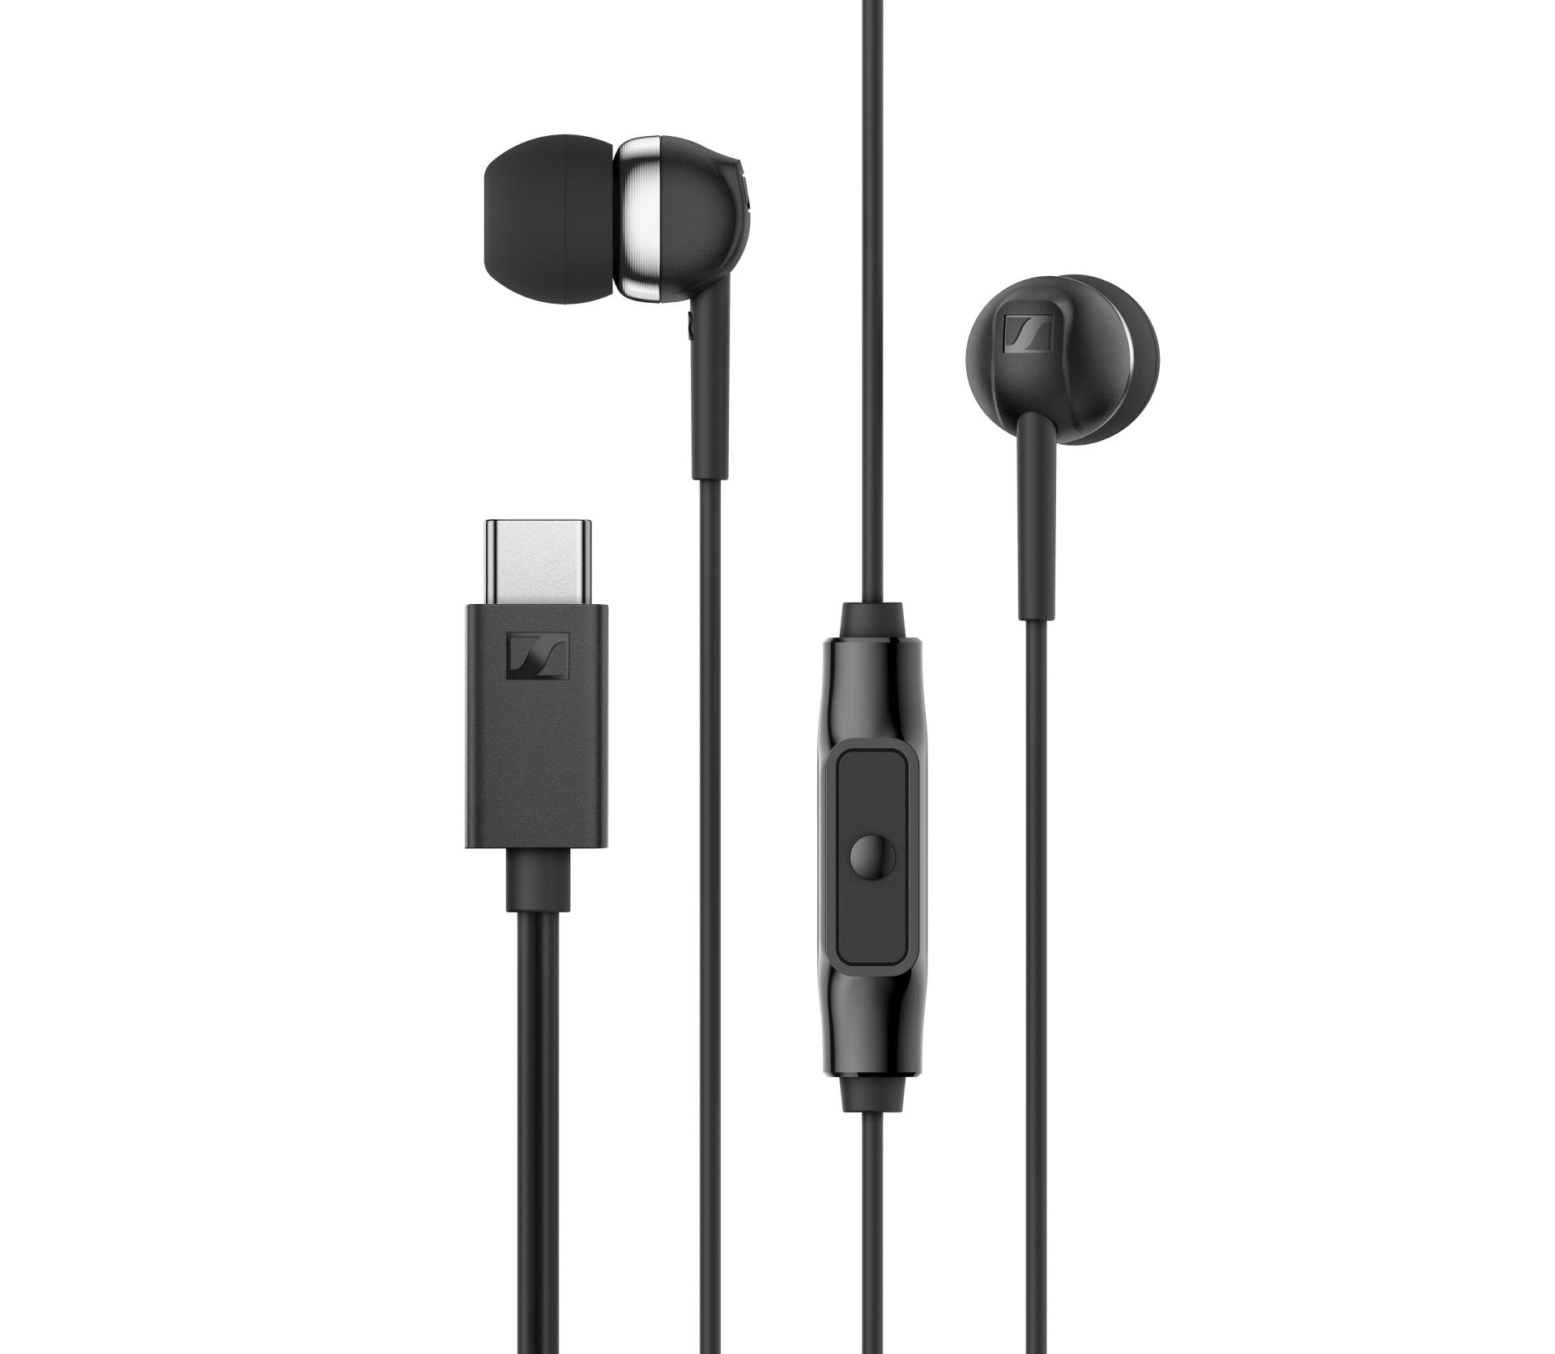
Compatibility & Availability
The USB interface for each offers class compliant, plug and play compatibility for iOS, iPadOS®, Android™, ChromeOS™, MacOS®, Windows®, SteamOS devices and more. Both the CX 80U and HD 400U utilize a MEMS microphone for low-noise, full-range voice pickup in a compact footprint.
The CX 80U (MSRP $39.95 USD / $49.95 CAD) and HD 400U (MSRP $99.95 USD / $139.95 CAD) are available today from authorized dealers and sennheiser-hearing.com.

Android™ and ChromeOS™ are trademarks of Google LLC. iPadOS® and macOS® are registered trademarks of Apple Inc., registered in the U.S. and other countries. iOS is a trademark or registered trademark of Cisco in the U.S. and other countries and is used under license by Apple Inc. Windows® is a registered trademark of Microsoft Corporation in the United States and/or other countries. SteamOS is a trademark of Valve Corporation. All other company and product names mentioned herein may be trademarks of their respective companies.

About the Sennheiser Brand – 80 Years of Building the Future of Audio
We live and breathe audio. We are driven by the passion to create audio solutions that make a difference. This passion has taken us from the world’s greatest stages to the quietest listening rooms – and made Sennheiser the name behind audio that doesn’t just sound good: It feels true. In 2025, the Sennheiser brand celebrated its 80th anniversary. Since 1945, we have stood for building the future of audio and bringing remarkable sound experiences to our customers. While professional audio solutions such as microphones, meeting solutions, streaming technologies and monitoring systems are part of the business of Sennheiser electronic SE & Co. KG, the business with consumer devices such as headphones, soundbars and speech-enhanced hearables is operated by Sonova Holding AG under the license of Sennheiser.

www.sennheiser.com
www.sennheiser-hearing.com

About Sonova Consumer Hearing
Sonova Consumer Hearing offers premium headphones and hearables – primarily in the true wireless segment – as well as audiophile headphones, hearing solutions and soundbars under the Sennheiser brand. The business is part of the Sonova Group, a global leader in innovative hearing care solutions with headquarters in Switzerland and more than 17,000 employees worldwide.

Press contact
Sonova Consumer Hearing USA
Eric Palonen
PR and Influencer Manager | Americas Headphone and Soundbars
T +1 860 908 1210
eric.palonen@sonova.com

